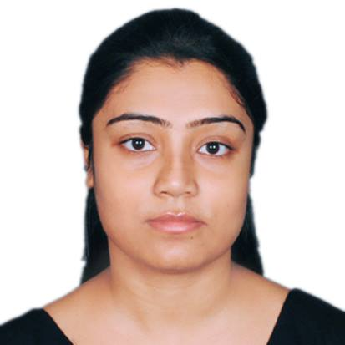
RITUPARNA PAL
912, S.H.K.Basu Sarani, Ramkrishna Park, Kolkata-700074 (Near Laketown)
Contact: +91- 9674973048 Email: pal_rituparna@yahoo.in

Seeking responsibilities with organizations of repute by utilizing my core competencies maximally for synergizing the objectives of the organization to strike a perfect balance between employer’s expectations and performance based growth.

PROFILE:

- MBA in Marketing with Three years of experience. Experienced in Administrative work, Back Office Operations, Customer Service, Online Sales, Customer relationship management in Kolkata, category development contributing towards enhancing and achieving profitability norms by adding to the volume & revenue growth of the company.
- Flair for charting out strategies with excellent communication, presentation skills and productive interaction with individuals at all levels.

EMPLOYMENT SCAN
COMPANY NAME: DEBLOK INDUSTRIES PVT. LTD.

CATEGORY: BAGS & RAINWEAR MANUFACTURING COMPANY

April 2015- Present
Admin In-Charge
Location: Kolkata
Industry: Manufacturer & Retailer

- Assist and support administrative staff in their day to day operations.
- Support Sales Staff in handling and documenting customer accounts.
- Assist inventory controlling staff in maintaining inventory records.
- Assist staffs in preparing goods in order to dispatch it on daily basis.
- Maintaining and updating all the data regularly using MS Excel.
- Work effectively with MS Office products ( Word, Excel, PowerPoint)

COMPANY NAME: MATRIMONY.COM LTD.

DEPARTMENT: MATRIMONY DIRECTORY (An Initiative of Bharat Matrimony)

Feb 2014- Feb 2015
Customer Relationship Executive
Location: Kolkata.
Industry: Online Media
Category: Wedding Classified Online Portal

- Build excellent customer relationship and ensure each registered Customers data is Complete and accurate
- Explain to the customers about the benefits of taking membership and support them to become a Paid Member
- Provide relevant Information to the queries of the existing customers providing Effective customer support services for customer retention and Renewal of membership.
- Identify, meet and prospect matrimony related vendors to win new business
- Responsible for database building and maintenance
- Generate leads and handle first and second level calls
- Maintain quality service by establishing and enforcing organization standards
- Responsible to developed and enhance business by interacted with various clients for repeat/ referral business through promotion of vendors with web based solutions.
- Generating new client base.

- Create alliances and partnerships to acquire and service new clients
- Responsible for building and growing client relationship by maintaining continuous engagement and regular servicing
- Create, execute and mange online campaigns to help Customer Brand
- Generation of Advertisement Revenue

INTERNSHIP DETAILS
COMPANY NAME: ITC LTD.

PROJECT NAME: Visual Merchandizing- Studying the Availability, Visibility and Market share of ITC Ltd. in modern trade format.

PROJECT DESCIRPTION- To visit all the ‘Arambagh Foodmart’ stores across Kolkata and study the availability of FMCG products of ITC and also the market shares of those products. Make a comparison with other competitive brands. Monitoring them and giving ideas how to improve the visibility of the products.

DURATION: 2 months (10th June to 10th August 2013)

EDUCATIONAL CREDENTIALS

DEGREE | INSTITUTE | YEAR | PERCENTAGE
MBA in Marketing & Finance | Institute of Engineering & Management (WBUT) | 2014 | 70
BBA | Techno India (WBUT) | 2012 | 78
12th (Science) | WBCHSE | 2009 | 60
10th | WBBSE | 2007 | 70.13

SOFTWARE KNOWLEDGE

Microsoft Office: Word, Excel, Access, PowerPoint and Outlook

PERSONAL DETAILS

Linguistic Ability: English, Hindi and Bengali.
Date of Birth: 25-09-1990
Sex: Female.
Place of Birth: Kolkata.
Marital Status: Single.
Current Location: Kolkata. WB, India

Family Background:

Father: Mr.Dipak Pal (Employee of United Bank of India)
Mother: Mrs. Bulbul Pal (Employee of Punjab National Bank of India)

I hereby confirm that the information in this document is accurate and true to the best of my knowledge.

Place: Kolkata
Date:

